Battery types

Batteries can be broadly divided into two major types.

* Primary Cell / Primary battery
* Secondary Cell / Secondary battery

Based on the application of the battery, they can be classified again. They are:

* Household Batteries

These are the types of batteries which are more likely to be known to the common man. They find uses in a wide range of household appliances (such as torches, clocks, and cameras). These batteries can be further classified into two subcategories:

* + Rechargeable batteries   
    Examples: Cadmium batteries, Lithium-Ion
  + Non-rechargeable batteries  
    Examples: Silver oxide, Alkaline & carbon zinc
* Industrial Batteries

These batteries are built to serve heavy-duty requirements. Some of their applications include railroad, backup power and more for big companies. Some examples are:  
Nickel Iron  
Wet Nickel Cadmium (NiCd)

* Vehicle Batteries

These are more user-friendly and a less complicated version of the industrial batteries. They are specifically designed to power cars, motorcycles, boats & other vehicles. An important example of a vehicle battery is the [Lead-acid battery](https://byjus.com/chemistry/lead-acid-battery/).

Primary Cell

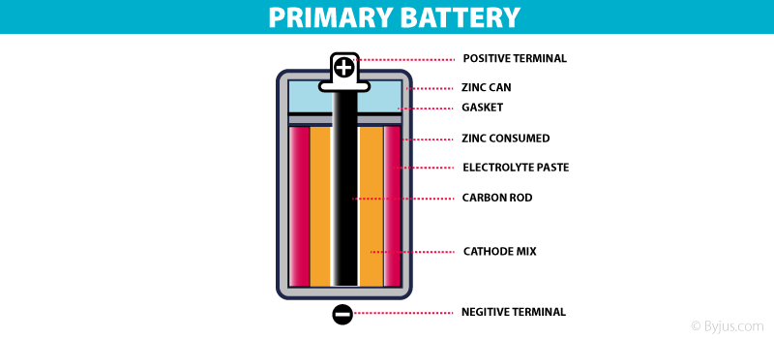

Types Of Battery- Primary battery

These are batteries where the redox reactions proceed in only one direction. The reactants in these batteries are consumed after a certain period of time, rendering them dead. A primary battery cannot be used once the chemicals inside it are exhausted.

An example of a primary battery is the dry cell – the household battery that commonly used to power TV remotes, clocks, and other devices. In such cells, a zinc container acts as the anode and a carbon rod acts as the cathode. A powdered mixture of [manganese dioxide](https://byjus.com/chemistry/manganese-dioxide/) and carbon is placed around the cathode. The space left in between the container and the rod are filled with a moist paste of ammonium chloride and zinc chloride.

The redox reaction that takes place in these cells is:

At Anode

**Zn(s) –> Zn2+ (aq) + 2e–**

At Cathode

**2e–+ 2 NH4+ (aq) –> 2 NH3(g) + H2 (g)**

**2 NH3(g) +Zn2+ (aq) –> [Zn (NH3)2]2+ (aq)**

**H2 (g) + 2 MnO2 (S) –> Mn2O3 (S) + H2O (l)**

Thus, the overall cell equation is:

**Zn(s) + 2 NH4+ (aq) + 2 MnO2 (S) –> [Zn(NH3)2]2+ (aq) + Mn2O3 (S) + H2O (l)**

Another example of the primary cell is the mercury cell, where a zinc-mercury amalgam is used as an anode and carbon is used as a cathode. A paste of HgO is used as an electrolyte. These cells are used only in devices that require a relatively low supply of electric current (such as hearing aids and watches).

Secondary Cell

These are batteries that can be recharged after use by passing current through the electrodes in the opposite direction, i.e. from the negative terminal to the positive terminal.

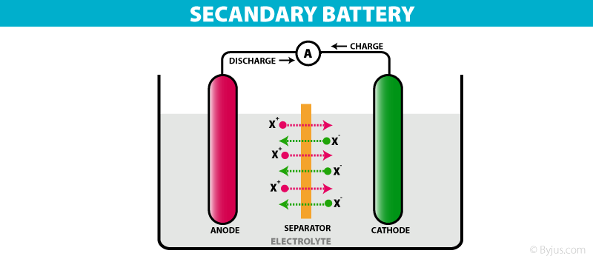

Types Of Battery – Secondary Cell

For example, a lead storage battery that is used in automobiles and inverters can be recharged a limited number of times. The lead storage battery consists of a lead anode and the cathode is a lead grid packed with lead dioxide. Sulphuric acid with a concentration of 38% is used as an electrolyte. The [oxidation and reduction reactions](https://byjus.com/chemistry/oxidation-and-reduction/) involved in this process are listed below.

At Anode

**Pb –> Pb2++ 2 e–**

**Pb+ SO42– –>PbSO4(electrode) + 2 e–**

At Cathode

**2 e–+ PbO2+ 4 H+ –> Pb2++ 2 H2O**

**2 e–+ PbO2+ 4 H++ SO42- –> PbSO4(electrode) + 2 H2O**

In order to recharge these batteries, the charge is transferred in the opposite direction and the reaction is reversed, thus converting PbSO4 back to Pb and [PbO2](https://byjus.com/chemistry/pbo2/).

Another example of the secondary cell is the nickel-cadmium cell. These cells have high storage capacities and their lifespan is relatively long (compared to other secondary cells). However, they are difficult to manufacture and maintain.

|  |  |
| --- | --- |
| **Difference Between Cell and Battery** | |
| Cell | Battery |
| A cell is a single unit device which converts chemical energy into electric energy. | A battery usually consists of group of cells. |
| Depending on the types of electrolytes used, a cell is either reserve, wet or dry types. Cell also includes  molten salt type. | A battery is either a primary battery or a secondary battery meaning it is rechargeable or non-chargeable. |
| A cell is usually light and compact as it has a single unit. | Battery normally consists of several cells thus giving it a bigger size and is bulky. |
| A cell supplies power for a shorter period of time. | A battery can supply power long durations. |
| A cell is used mostly for lighter tasks  which requires less energy. It is used in  lamps, clocks, lamp, etc. | A battery is mostly used for heavy-duty tasks. It is used in inverters, automobiles, inverter, etc. |
| Cells are usually cheap | Batteries are much costlier. |

## Difference Between Primary Cell and Secondary Cell

Primary cells are the ones which cannot be recharged and have to be discarded after the expiration of the lifetime whereas, secondary cells need to be recharged when the charge gets over. Both the [types of battery](https://byjus.com/chemistry/battery-types/) are used extensively in various appliances and these cells differ in size and material used in them.

|  |  |
| --- | --- |
| Difference Between Primary Cell and Secondary Cell | |
| **Primary Cell** | **Secondary Cell** |
| Have high energy density and slow in discharge and easy to use | They are smaller energy density |
| There are no fluids in the cells hence it is also called as dry cells | There are made up of wet cells (flooded and liquid cells) and molten salt (liquid cells with different composition) |
| It has high internal resistance | It has a low internal resistance |
| It has an irreversible chemical reaction | It has a reversible chemical reaction |
| Its design is smaller and lighter | Its design is more complex and heavier |
| Its initial cost is cheap | Its initial cost is high |

**Lead Acid Batteries**

• ***Introduction***

The best known and most widely used battery for electric vehicles is the lead acid battery. Lead acid batteries are widely used in IC engine vehicles and as such are well known. However for electric vehicles, more robust lead acid batteries that withstand deep cycling and use a gel rather than a liquid electrolyte are used. These batteries are more expensive to produce. In the lead acid cells the negative plates have a spongy lead as their active material, whilst the positive plates have an active material of lead dioxide. The plates are immersed in an electrolyte of dilute sulphuric acid. The sulphuric acid combines with the lead and the lead oxide to produce lead sulphate and water, electrical energy being released during the process. The overall reaction is:



The reactions on each electrode of the battery are shown in Fig. In the upper part of the diagram the battery is discharging. Both electrode reactions result in the formation of lead sulphate. The electrolyte gradually loses the sulphuric acid, and becomes more dilute. When being charged, as in the lower half of **Figure**, the electrodes revert to lead and lead dioxide. The electrolyte also recovers its sulphuric acid, and the concentration rises. The lead acid battery is the most commonly used rechargeable battery in anything but the smallest of systems. The main reasons for this are that the main constituents (lead, sulphuric acid, a plastic container) are not expensive, that it performs reliably, and that it has a comparatively high voltage of about 2V per cell.

